**Experiment No 1**

**Aim**: Hadoop Installation and basic commands

**Requirements**: Linus/Windows OS, zip extractor (windows) to extract tar file, Open TCP Ports.

**Theory**:

The Hadoop Distributed File System (HDFS) is a distributed file system designed to run on commodity hardware. It has many similarities with existing distributed file systems. However, the differences from other distributed file systems are significant. HDFS is highly fault-tolerant and is designed to be deployed on low-cost hardware. HDFS provides high throughput access to application data and is suitable for applications that have large data sets. HDFS relaxes a few POSIX requirements to enable streaming access to file system data. HDFS was originally built as infrastructure for the Apache Nutch web search engine project. HDFS is part of the Apache Hadoop Core project.

**Installation**:

1. Download Hadoop from https://dlcdn.apache.org/hadoop/common/ compatible version (my version – 2.10)

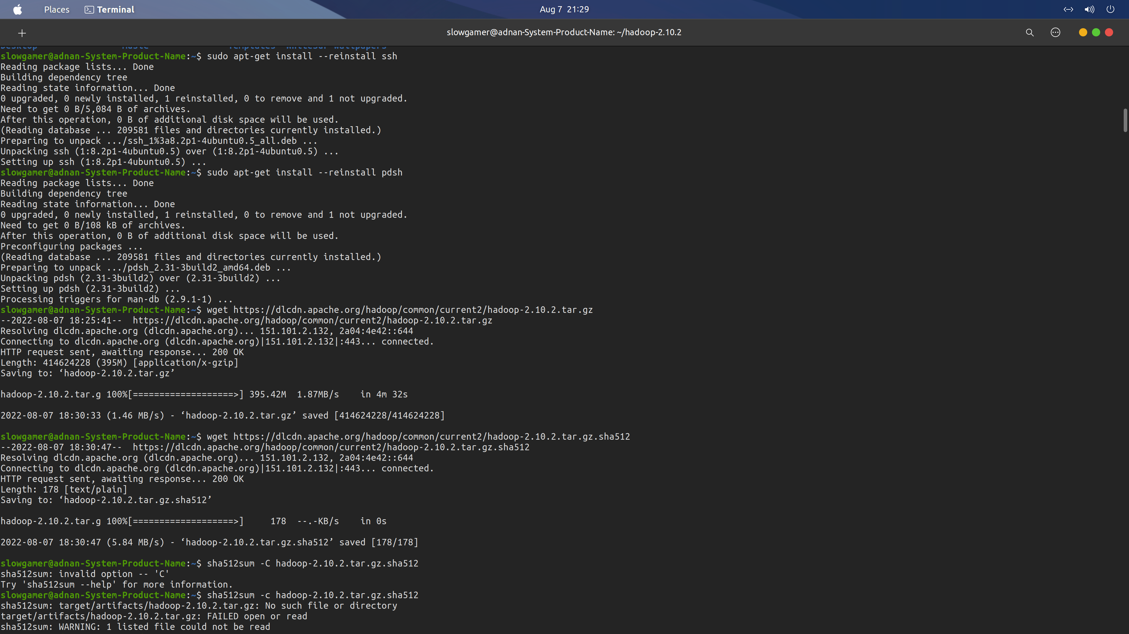

2. Install ssh and pdsh for creating asymmetric keys with hdfs

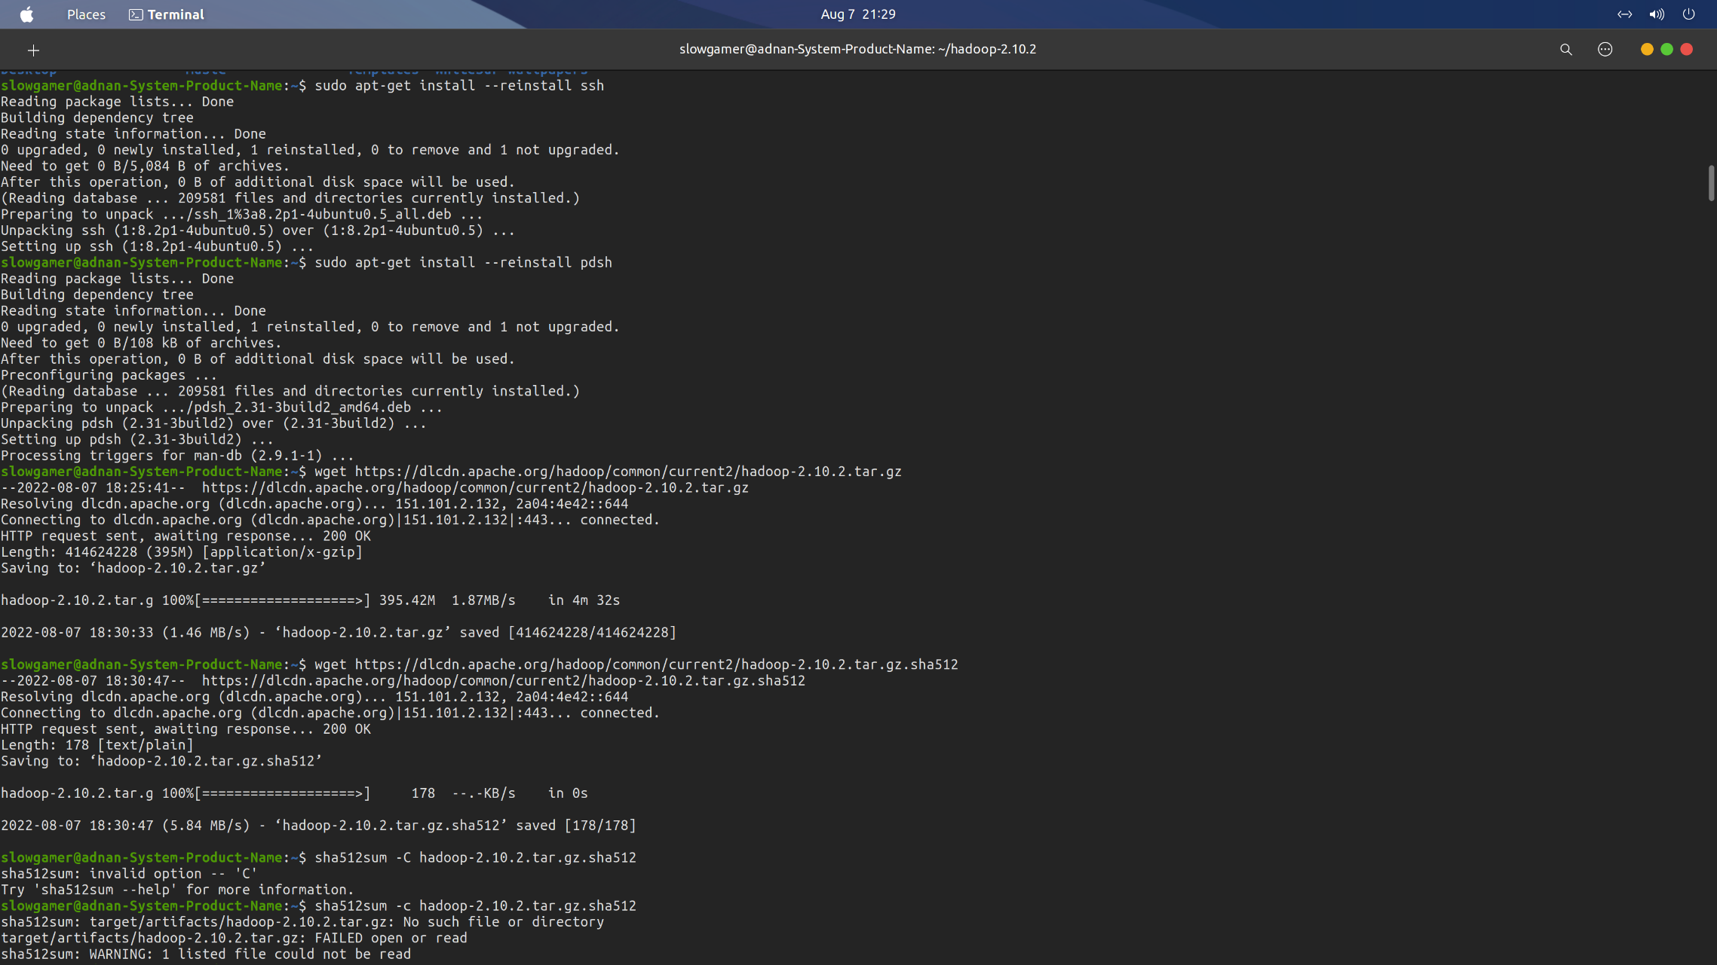

3. Extract the tar file and cd into extracted hadoop-version file and check in bin for runnable file hadoop if it is working

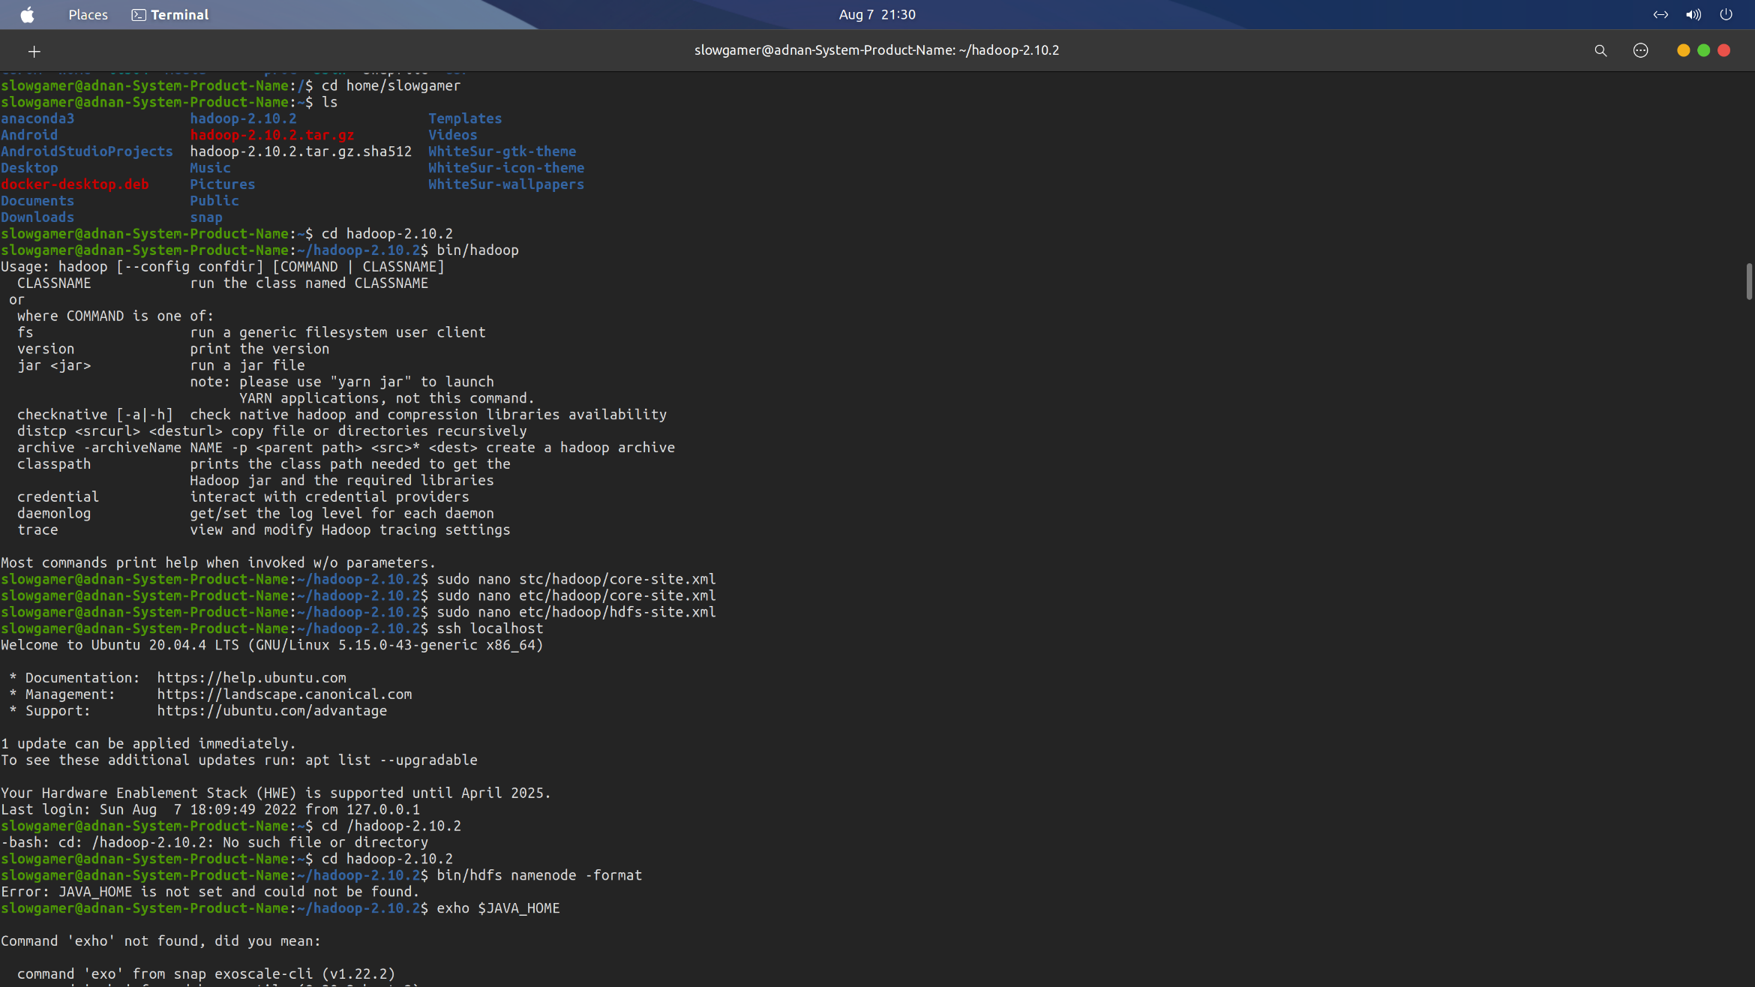

4. Change settings of core-site.xml and hdfs-site.xml present in etc/hadoop as given by hadoop docs

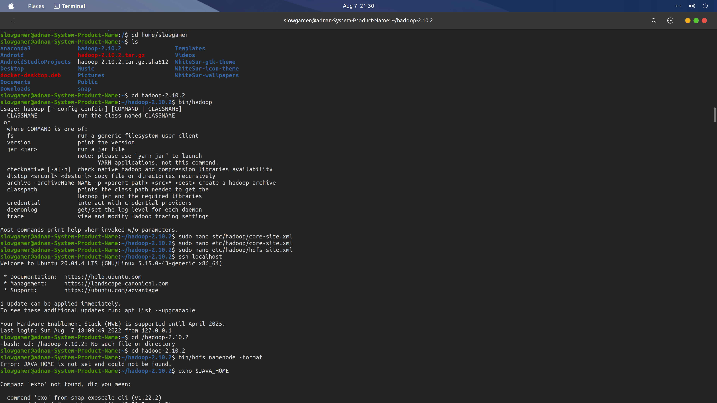

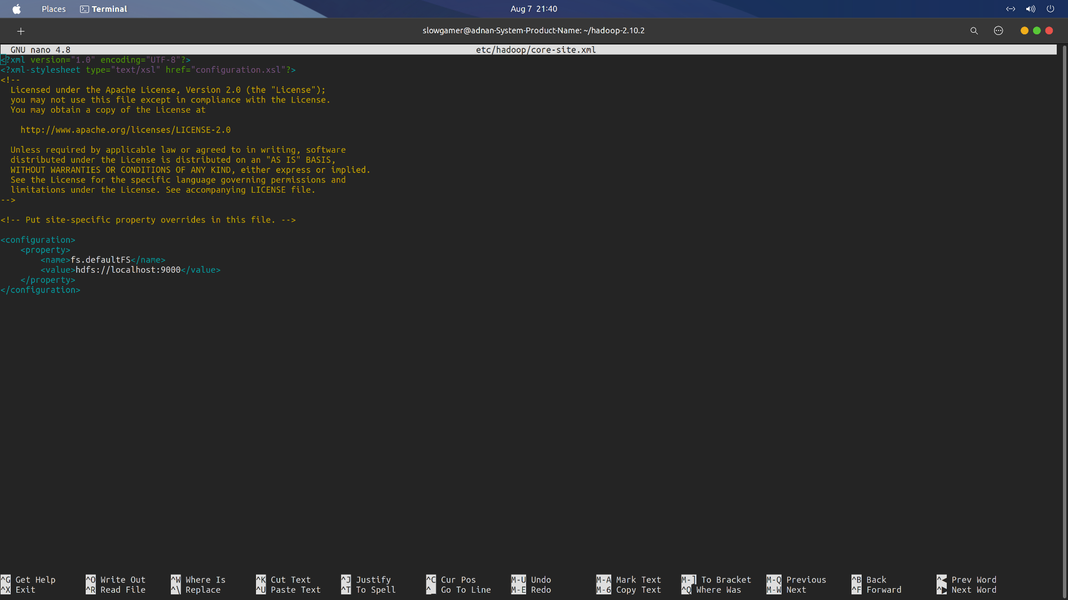

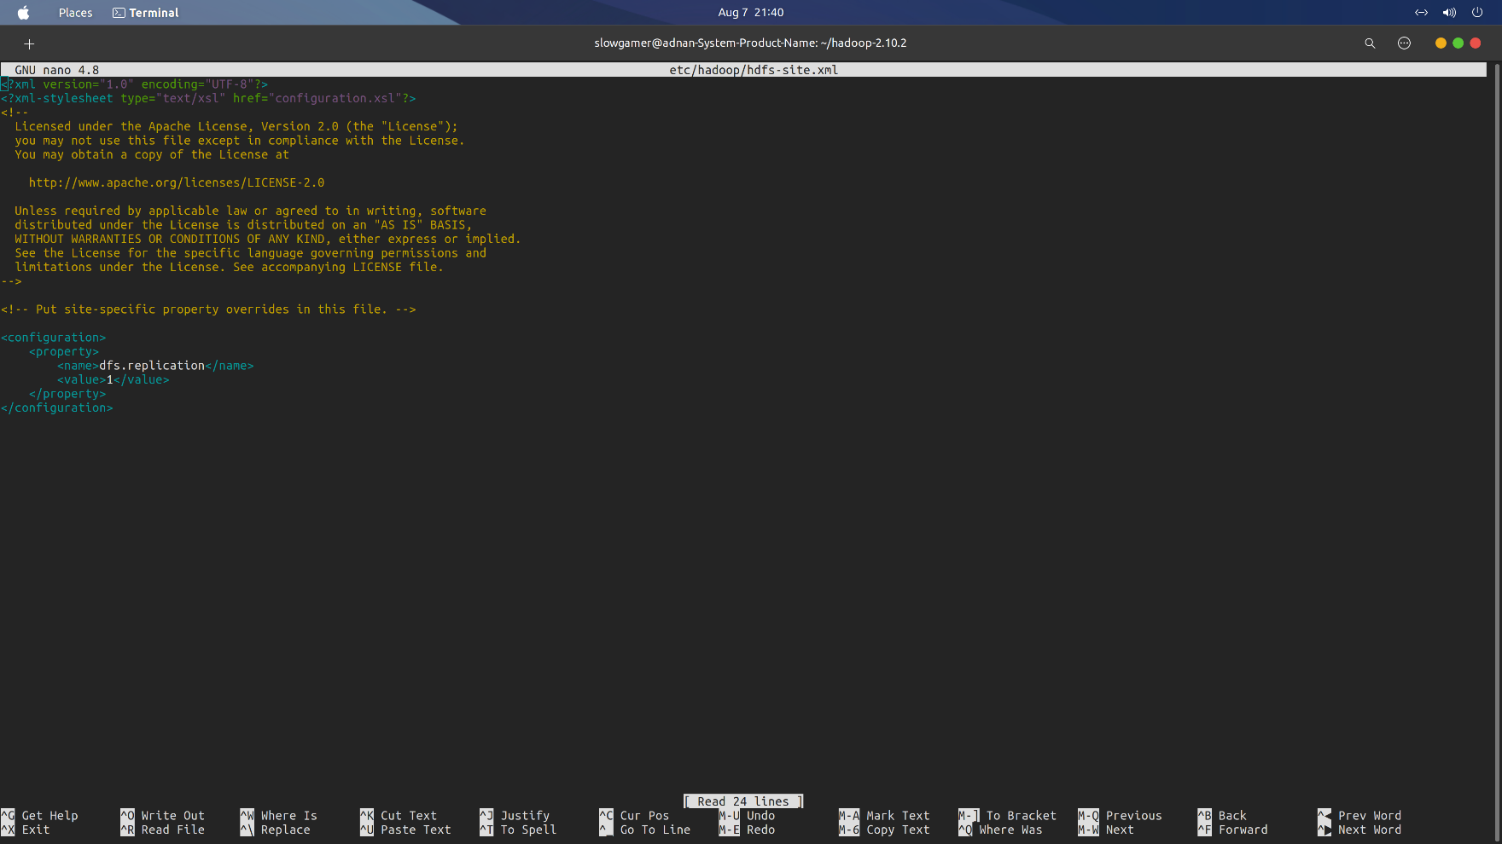

5. Set JAVA_HOME in etc/hadoop/hadoop-env.sh to jdk 8 folder

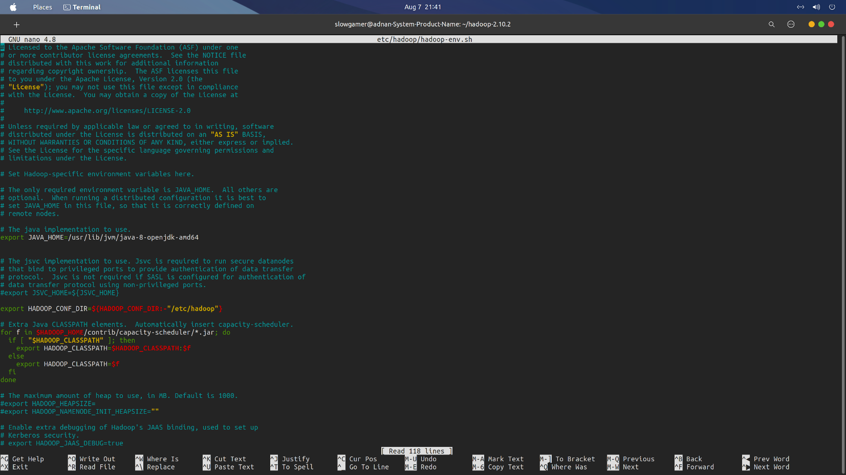

6. Connect ssh to localhost



7. Format Name node

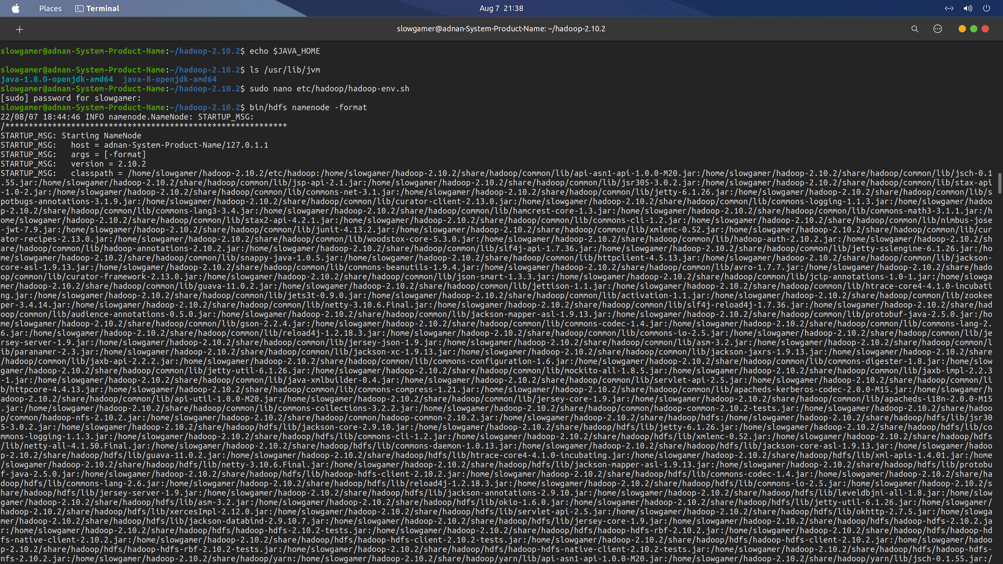

8. Change settings of yarn-site.xml and mapred-site.xml present in etc/hadoop as given by hadoop docs

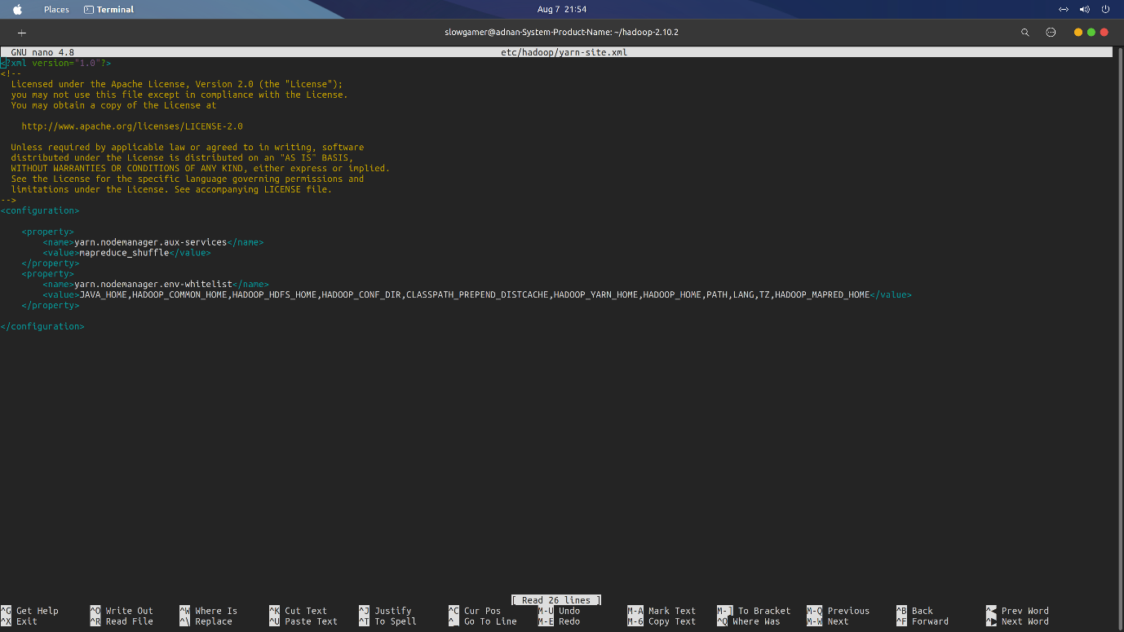

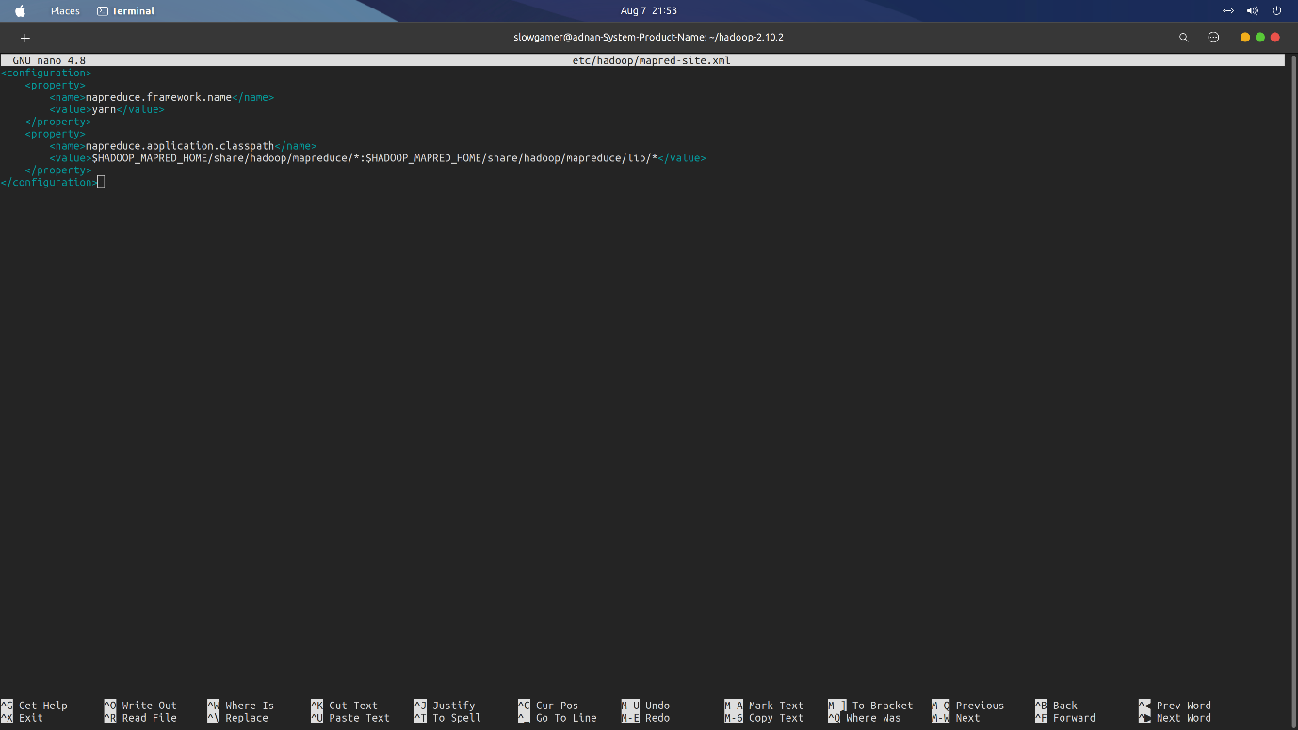

9. Start dfs and yarn services using following commands and check if they’re working on ports 8088 and 50075

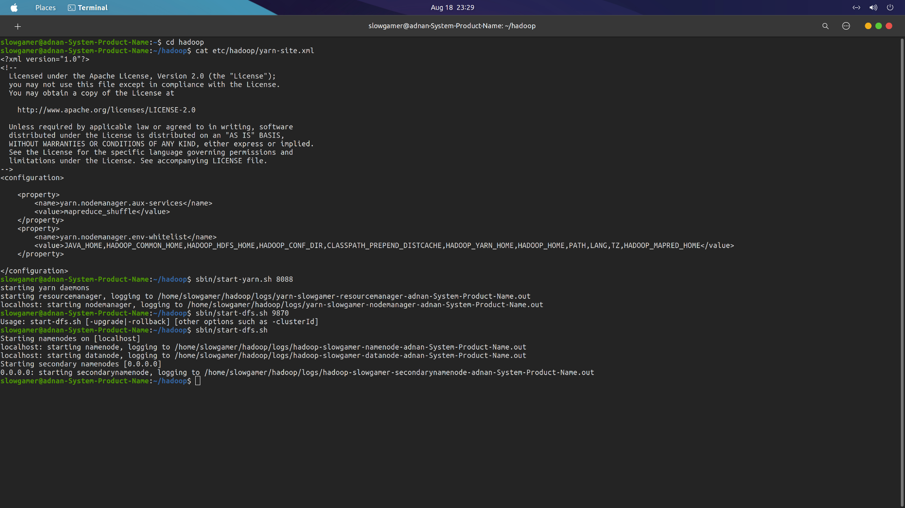

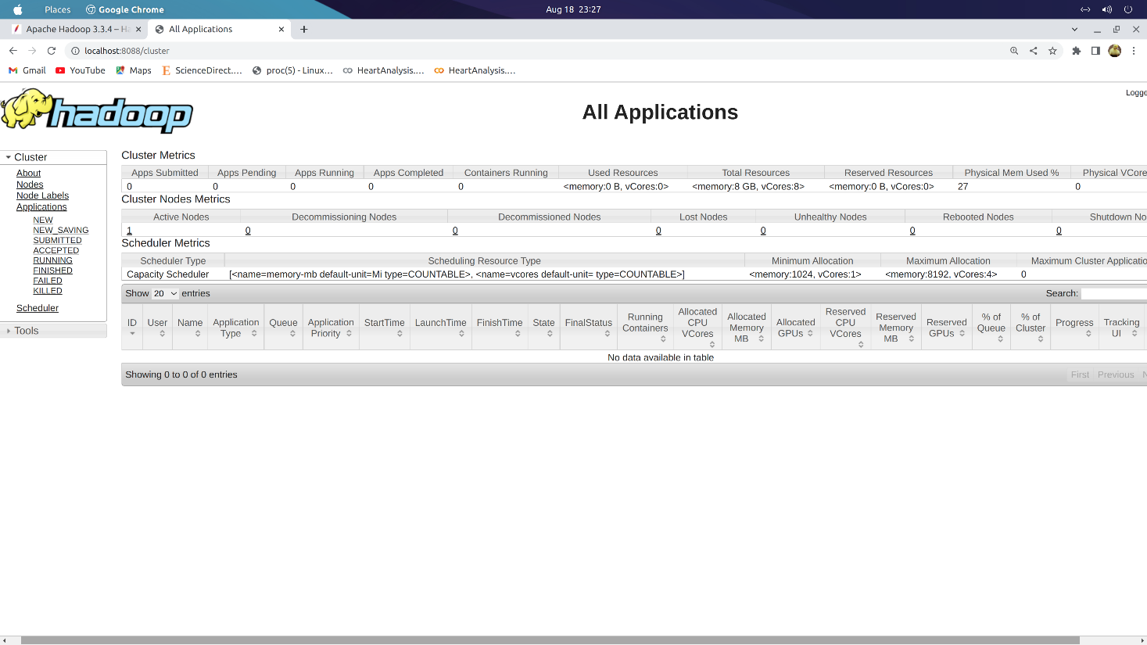



**HDFS basic commands**:

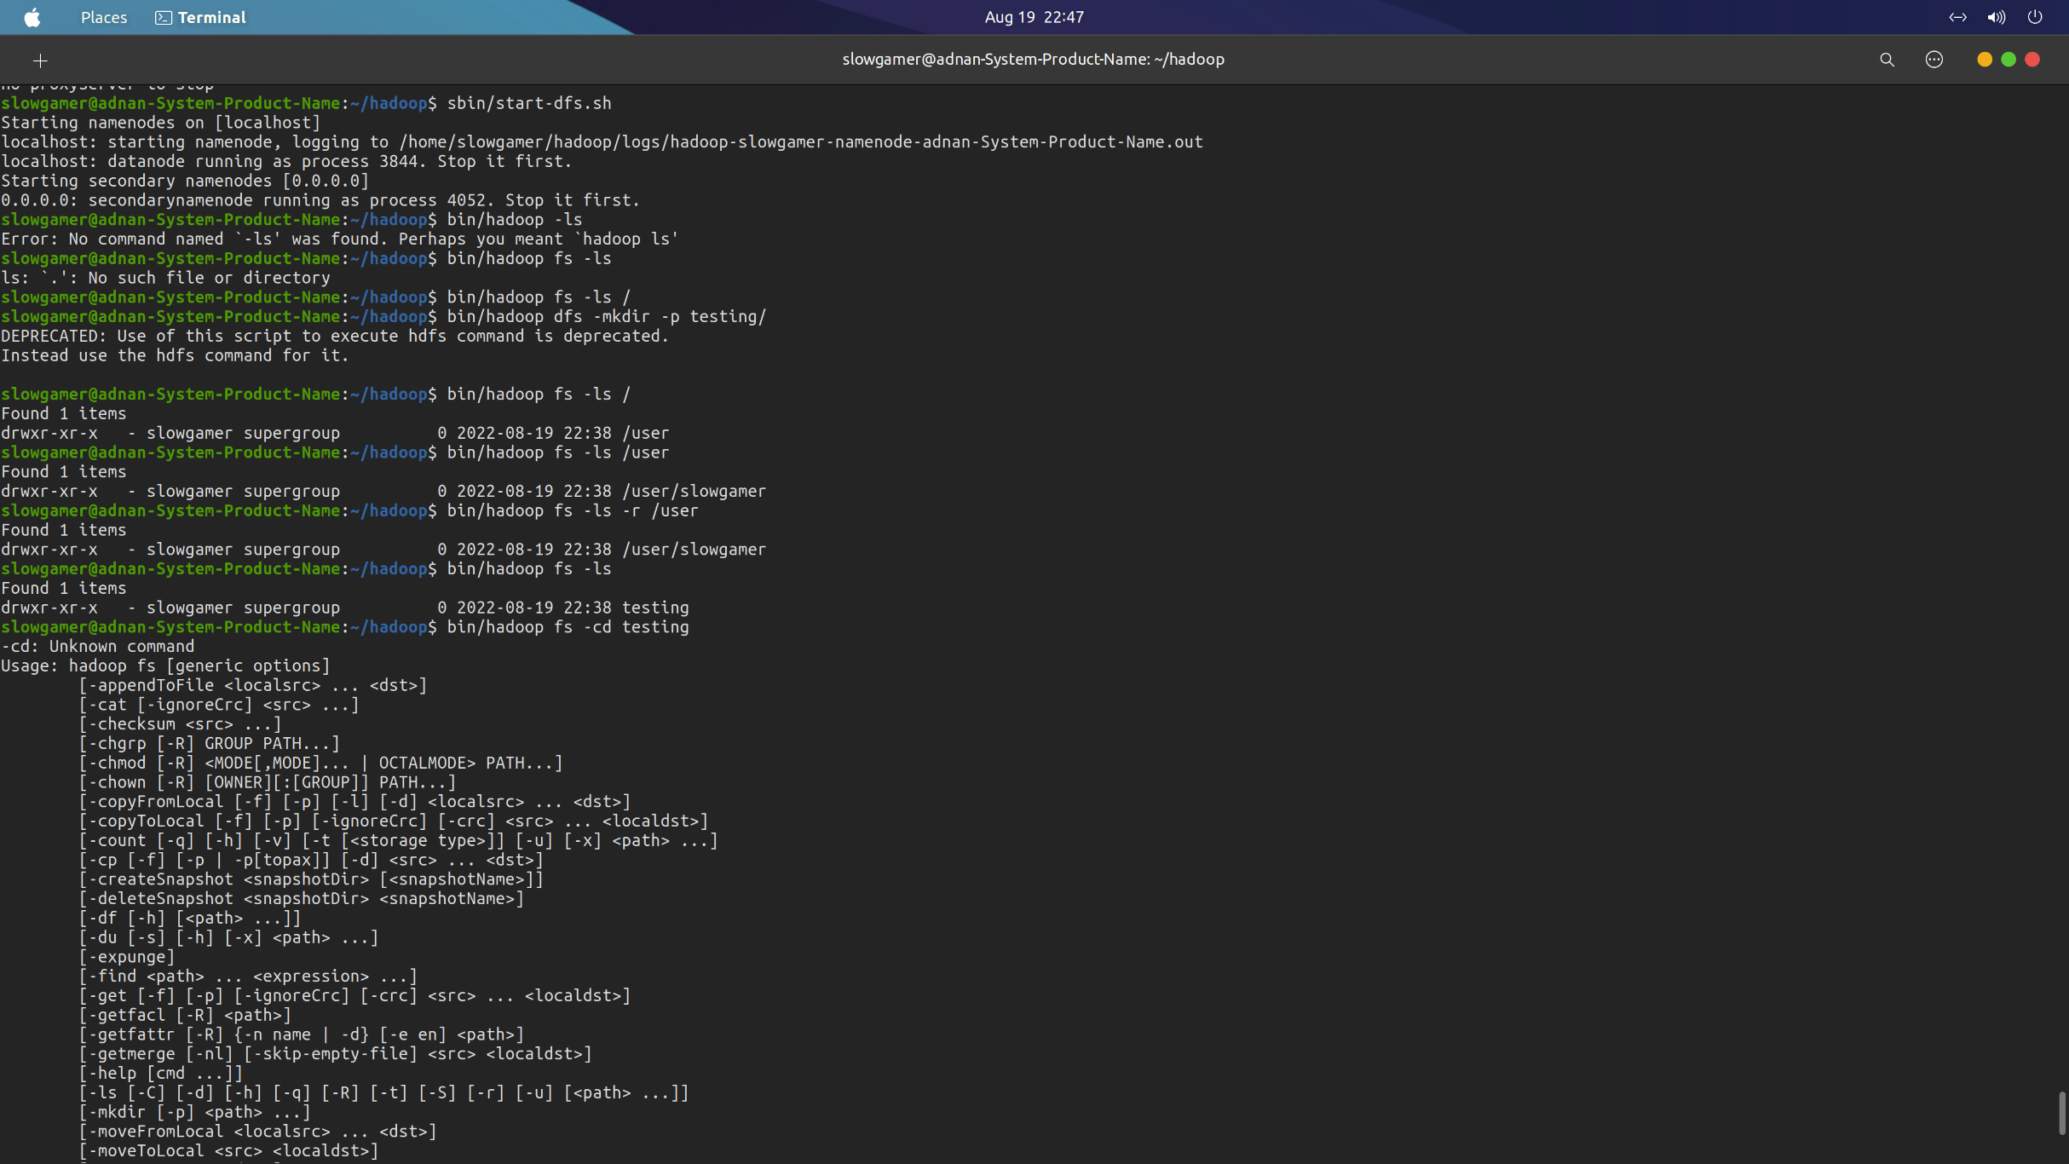

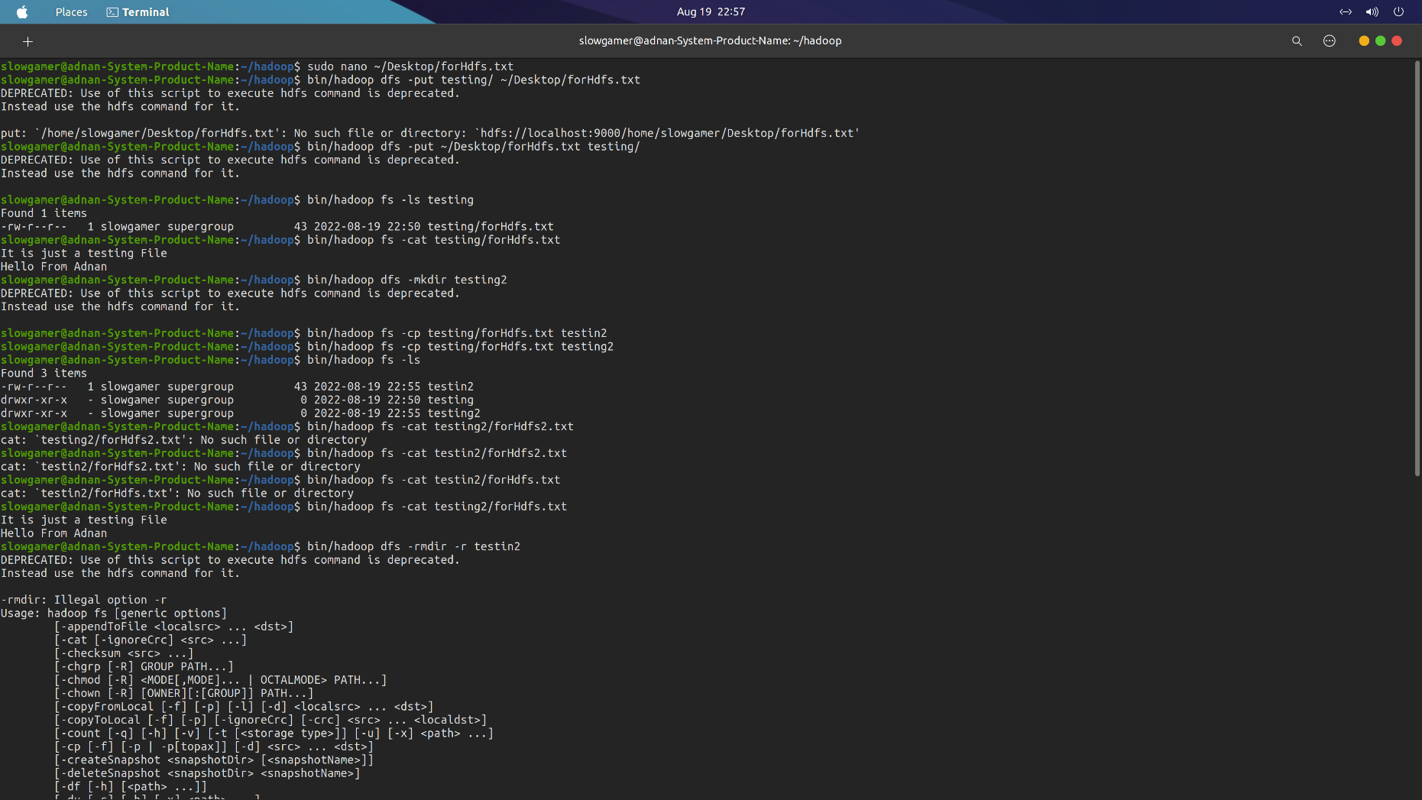

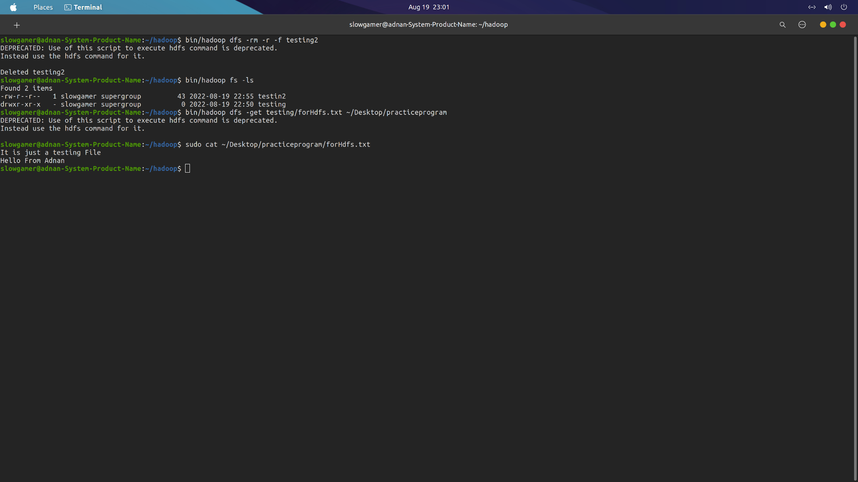

**Conclusion**: We have successfully installed Hadoop and implemented the Hadoop basic commands